ENGG104 Laboratory Report

Student Name & Number

Experiment Number

Introduction
This is where you introduce the experiment clearly stating what the aim was. Introduce and explain any theoretical concepts associated with the experiment. This should be about a page long. This is where you introduce the experiment clearly stating what the aim was. Introduce and explain any theoretical concepts associated with the experiment. This should be about a page long. This is where you introduce the experiment clearly stating what the aim was. Introduce and explain any theoretical concepts associated with the experiment. This should be about a page long.

Method
Briefly describe how the experiment took place. This is not a copy/paste of the procedures, but rather a summary of how the experiment was done. This should be no longer than half a page. Briefly describe how the experiment took place. This is not a copy/paste of the procedures, but rather a summary of how the experiment was done. This should be no longer than half a page. Briefly describe how the experiment took place. This is not a copy/paste of the procedures, but rather a summary of how the experiment was done. This should be no longer than half a page. Briefly describe how the experiment took place. This is not a copy/paste of the procedures, but rather a summary of how the experiment was done. This should be no longer than half a page.

Results & Discussion
Showcase your results and compare to expected results. Explain what happened when undertaking your experiment. Did things go wrong? If they did why? Do your results match what you would expect in theory? What did you learn from undertaking the experiment? The results section should contain the most text – approximately three pages. Captions for tables are at the top and captions for figures are at the bottom. Note that table captions should be in Roman numeral format.
Table I: Mechanical Material Properties
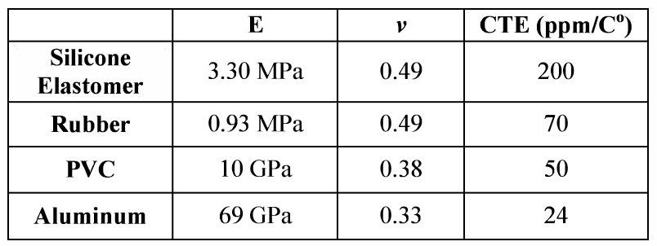
Showcase your results and compare to expected results. Explain what happened when undertaking your experiment. Did things go wrong? If they did why? Do your results match what you would expect in theory? What did you learn from undertaking the experiment? The results section should contain the most text – approximately three pages. Captions for tables are at the top and captions for figures are at the bottom. Note that table captions should be in Roman numeral format.
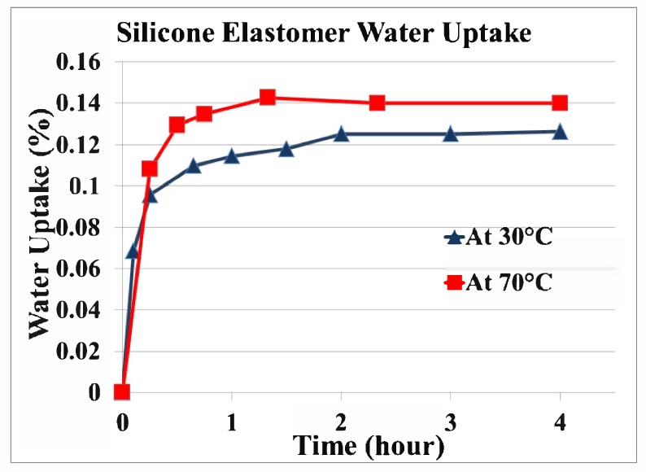
Figure 1: Silicone elastomer water absorption behaviour at 35 and 75 degrees Celsius
Showcase your results and compare to expected results. Explain what happened when undertaking your experiment. Did things go wrong? If they did why? Do your results match what you would expect in theory? What did you learn from undertaking the experiment? The results section should contain the most text – approximately three pages. Captions for tables are at the top and captions for figures are at the bottom. Note that table captions should be in Roman numeral format.

Conclusion
The conclusion brings closure to the reader, summing up your points or providing a final perspective on your experiment. This should be only one or two paragraphs long. The conclusion brings closure to the reader, summing up your points or providing a final perspective on your experiment. This should be only one or two paragraphs long.

References
List all the sources of information you used throughout the laboratory report. Use the IEEE referencing style for your references. See the following for style information: http://www.ieee.org/documents/ieeecitationref.pdf

